Clarifications of this project: The point of this project was to streamline MOO’s auditing to make sure employees were being deducted for the benefit properly. Employees needed automation to move away from how tedious the auditing was to do manually.

Starting workbook contained two sheets

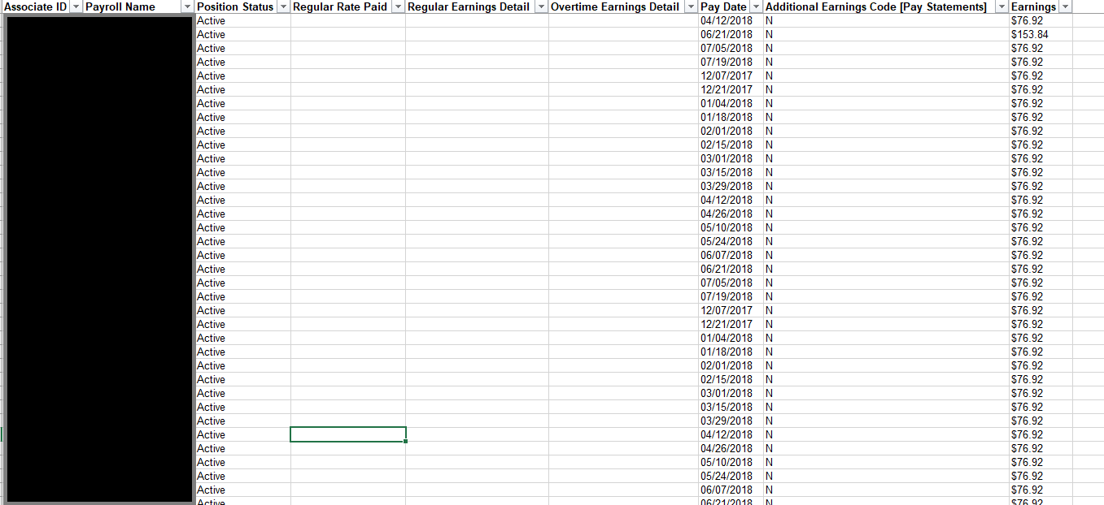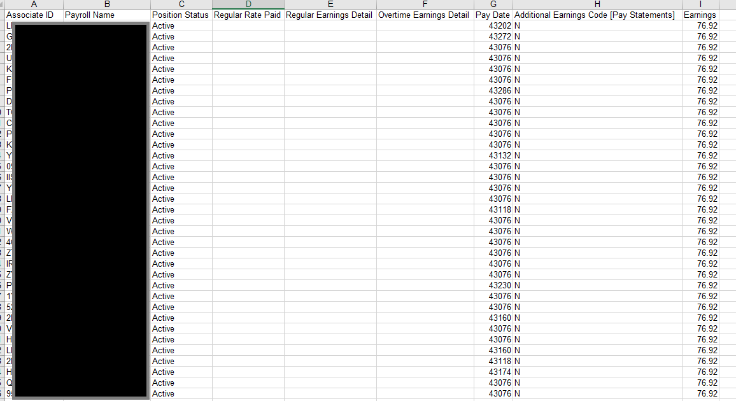

The Two sheets contained correct deduction amounts per month per employee, and the other sheet contained historical deduction data for the year per employee. The Macro Simple reported who had a deduction error and highlighted that. The last Sheet created by Macro: shet3 would give all the employees with deduction issues and would highlight where errors were.

Results: The macros will also format to make results cleaner to look trough.

